HWA CHONG INSTITUTION

C2 PRELIMINARY EXAMINATION
H1 CHEMISTRY 8872/01
PAPER 1
Multiple Choice
24 September 2010 1 hour

Do not open this booklet until you are told to do so.

READ THESE INSTRUCTIONS FIRST
Write in soft pencil.
Do not use staples, paper clips, highlighters, glue or correction fluid.
Complete the information on the optical mark sheet (OMS) as shown below.
Write your name
Write your CT group

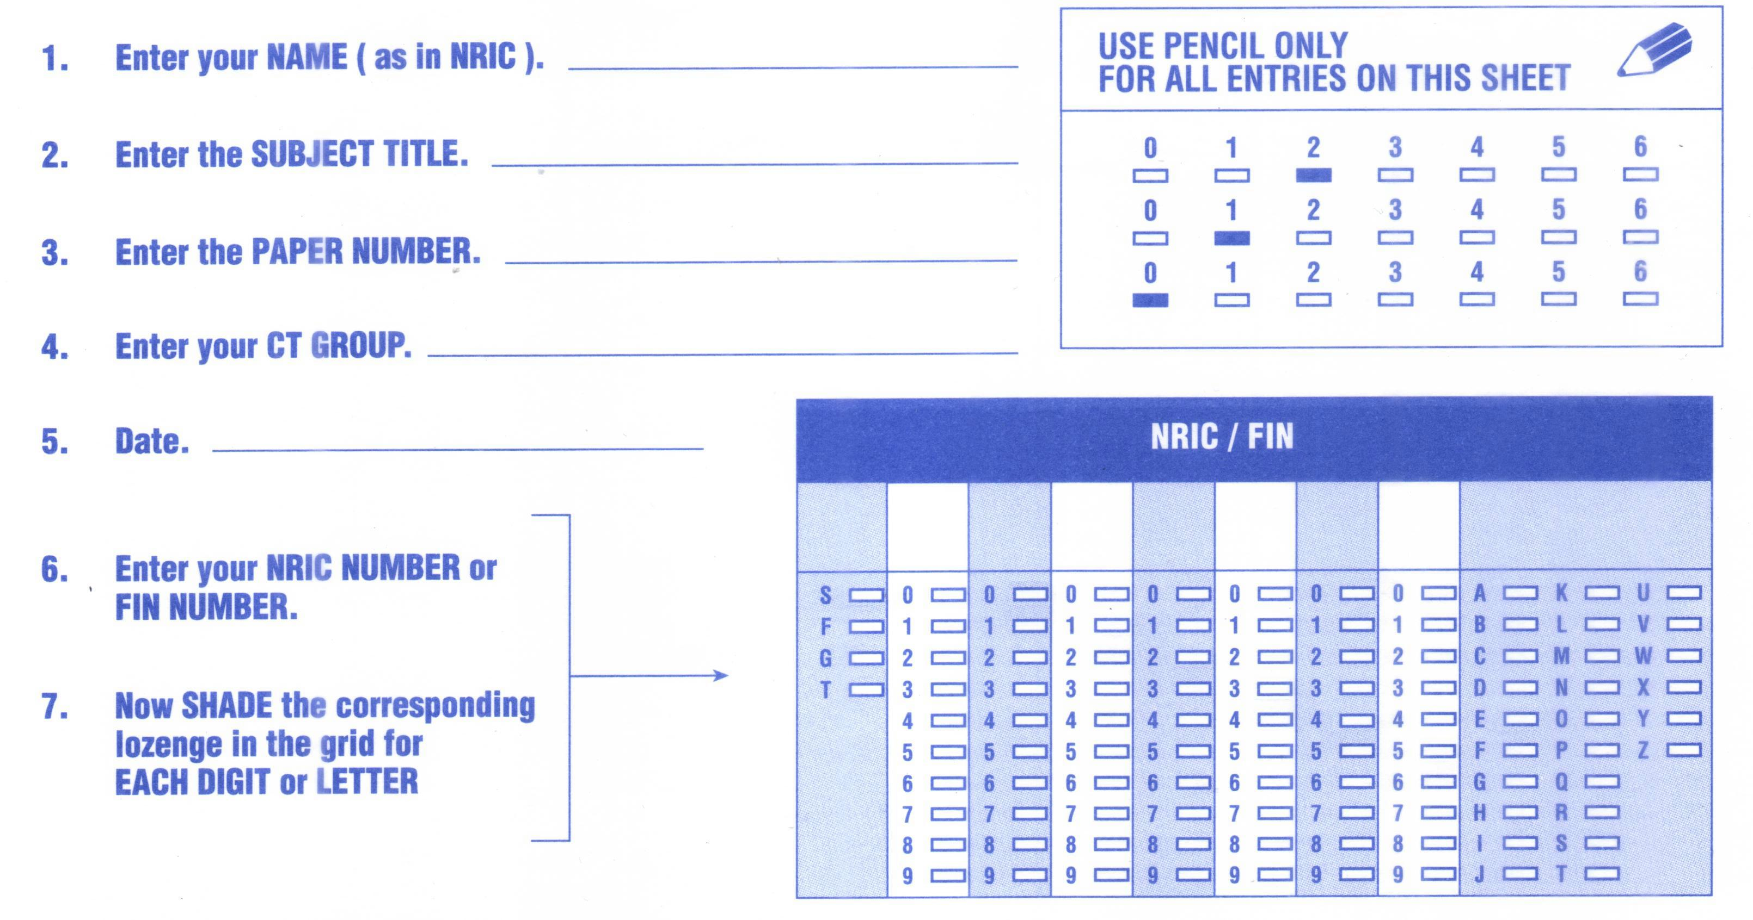
Write and shade your NRIC
or FIN number

There are thirty questions on this paper. Answer all questions. For each question, there are four possible answers A, B, C and D.
Choose the one you consider correct and record your choice in soft pencil on the OMS.

Each correct answer will score one mark. A mark will not be deducted for a wrong answer.
Any rough working should be done in this booklet.
Section A
For each question, there are four possible answers, A, B, C and D. Choose the one you consider to be correct.
1 | Which of the following statements is correct?
A | 24 dm³ of hydrogen gas at 25 °C and 1 atm contains 6.0 ×10²³ hydrogen atoms.
B | 500 cm³ of 1 mol dm⁻³ aqueous copper(II) nitrate, Cu(NO₃)₂, contains 3.0 × 10²³ nitrate ions.
C | 256 g of sulfur contains 6.0 ×10²³ S₈ molecules.
D | 1 mole of sodium hydrogensulfate, NaHSO₄, dissolves in water to form 1.8 × 10²⁴ ions.

2 |  | When 10 cm³ of a gaseous hydrocarbon was completely burnt in excess oxygen, 30 cm³ of carbon dioxide and 40 cm³ of water vapour were formed.  Given that all volumes were measured at the same temperature and pressure, what is the formula of the hydrocarbon?
  A | C₂H₂ | B | C₂H₆ | C | C₃H₄ | D | C₃H₈
3 | Which of the following ions has more electrons than protons and more neutrons than protons? [T = 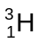]
  A | T⁻ | B | He⁺ | C | OH⁻ | D | H₃O⁺

4 | An element X forms an ion X^{n+}.  Which of the following statements about X and X^{n+} is correct?
A | The radius of X^{n+} is greater than that of X.
B | The number of protons in X^{n+} is greater than that of X.
C | Less energy is released when an electron is added to X^{n+} than to X.
D | More energy is required to remove the outermost electrons from X^{n+} than from X.

5 | 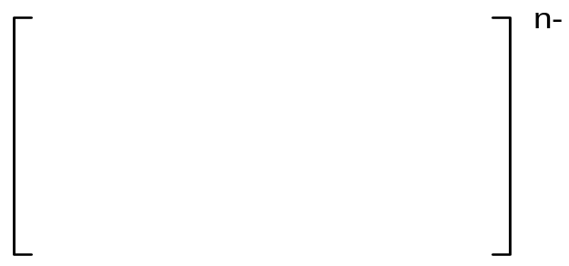  An ion IF₄^{n-} has a square planar structure as shown below.  I  F  F  F  F  What is the value of n?
  A | 1 | B | 2 | C | 3 | D | 4
6 | Ice is the crystalline form of water. The diagram below shows part of the structure of ice.  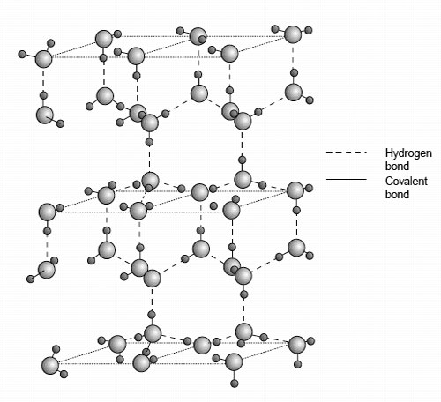  Which of the following statements is not true about ice?
A | Ice has a lower density than water at 0 ºC due to its open structure.
B | The bond angle about oxygen in ice is 109.5º.
C | Ice has a giant covalent structure.
D | Ice does not conduct electricity.

7 |  |  | When 13.08 g of zinc was added to 250 cm³ of 1.0 mol dm⁻³ aqueous copper(II) sulfate, the temperature of the solution rose by 15 ºC.  [Specific capacity of the final solution is 4.20 J g⁻¹ K⁻¹.]  Cu²⁺(aq) + Zn(s) → Zn²⁺(aq) + Cu(s)  What is the enthalpy change (in kJ mol⁻¹) for the above reaction?
 |  |  | A |  |  |  | −82.9 B −78.8
 |  |  | C |  |  |  | −66.3 D −4.12
 | 8 |  |  | Given: KOH(aq) + HBr(aq) → KBr(aq) + H₂O(l) ΔH_{r} = −57 kJ mol⁻¹  Which of the following will have the same value for the enthalpy change of reaction, ΔH_{r}, as the above reaction?
  A | NH₃(aq) + HBr(aq) → NH₄Br(aq) + H₂O(l)
  B | NaOH(aq) + ½H₂SO₄(aq) → ½Na₂SO₄(aq) + H₂O(l)
  C | ½Ba(OH)₂(aq) + CH₃CO₂H(aq) → ½Ba(CH₃CO₂)₂(aq) + H₂O(l)
  D | Ba(OH)₂(aq) + 2HNO₃(aq) → Ba(NO₃)₂(aq) + 2H₂O(l)
 |  | 9 |  |  | Potassium-argon dating is used to determine the age of igneous rocks. Potassium in these rocks gradually breaks down into argon and the gas is trapped in the rock. This radioactive decay is first order reaction with a half-life of 1.3 x 10⁹ years.  A sample of igneous rock, containing some potassium, is examined. If the amount of argon gas measured is 7 times as much as the amount of potassium, what is the age (in years) of the rock?
 |  |  |  |  | A | 1.3 x 10⁹ |  | B | 2.6 x 10⁹
 |  |  |  |  | C | 3.9 x 10⁹ |  | D | 9.1 x 10⁹

10 | An experiment was carried out to investigate the initial rate of reaction between K₂S₂O₈(aq), an oxidising agent, and KI(aq). The initial concentrations of K₂S₂O₈(aq) and KI(aq) in the mixture together with the time taken for the mixture to darken for the various experimental runs are given below.
 | Initial [K₂S₂O₈] / mol dm⁻³ | Initial [KI] / mol dm⁻³ | Time taken to darken / seconds
 | 0.10 | 0.20 | 35
 | 0.05 | 0.20 | 70
 | 0.10 | 0.067 | 105
 | 0.02 | 0.75 | Y
 | What is the value of Y in the table?
  A | 72 | B | 60 | C | 47 | D | 40

11 | An experiment is set up to measure the rate of hydrolysis of ethyl ethanoate.  CH₃CO₂CH₂CH₃ + H₂O CH₃CO₂H + CH₃CH₂OH  The hydrolysis is found to be slow in neutral aqueous solution, but proceeds at a measurable rate when the solution is acidified with hydrochloric acid.  What is the function of hydrochloric acid in the reaction mixture?
A | to maintain a constant pH during the reaction
B | to ensure that the reaction reaches equilibrium
C | to increase the reaction rate by catalytic action
D | to suppress ionisation of the ethanoic acid formed

12 | Given: A₂(g) + 4B(g) ⇌ 2AB₂(g) K_{c} = 4.8 (numerical value).  What is the value of K_{c} for the following reaction?  AB₂(g) ⇌ ½A₂(g) + 2B(g)
 | A | 2.4 | B | 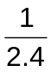
 | C | 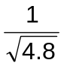 | D | 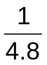

13 | The table below shows the values of the ionic product of water, K_{w}, at two different temperatures.  Which of the following is correct for pure water at 62 ºC?
  Temperature / ºC | K_{w} / mol² dm⁻⁶
  25  62 | 1.00 x 10⁻¹⁴  1.00 x 10⁻¹³
A | [H⁺] > [OH⁻] | B | pH = 7
C | pOH < 7 | D | pH = 14 - pOH

14 | Ga, Ge, As and Se are successive elements in Period 4 of the Periodic Table.  Which of the following statements is true?
A | Ga²⁺ and Ni are isoelectronic.
B | Both Ge and Se have two unpaired electrons at ground state.
C | First ionisation energy increases from Ga to Se.
D | As has only three unpaired electrons, thus the highest chloride formed is AsCl₃.

15 | One mole of magnesium, aluminium and sulfur are each completely burnt in an excess of oxygen gas.  Which graph shows the volume of oxygen used in each case?
A | x  x  x  volume of oxygen used  0  MgAl S | B | x  x  x  volume of oxygen used  0  MgAl S
C | volume of oxygen used  0  MgAl S  x  x  x  D | x  x  x  volume of oxygen used  0  MgAl S

16 | The following reaction scheme shows the synthesis of compound C from methylbenzene through a series of reactions.  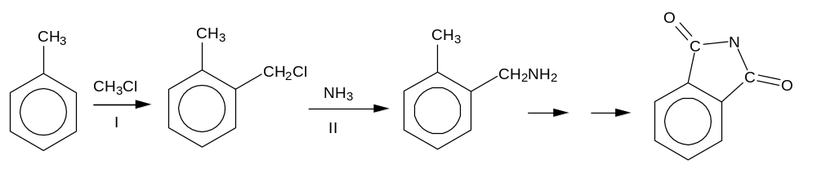  I  II  compound C  Which of the following shows the correct reaction types for steps I and II?
   | I | II
  A | addition | addition
  B | addition | condensation
  C | substitution | substitution
  D | substitution | elimination
17 | Compound E, C₄H₁₀, reacts with chlorine gas in the presence of light to form two monochlorinated alkanes, F and G, in an approximate molar ratio of 9 : 1.  What are the structures of E and F?
 | E | F
A | CH₃CH(CH₃)CH₃ | CH₃CH(CH₃)CH₂Cl
B | CH₃CH(CH₃)CH₃ | CH₃CCl(CH₃)CH₃
C | CH₃CH₂CH₂CH₃ | CH₃CH₂CHClCH₃
D | CH₃CH₂CH₂CH₃ | CH₃CH₂CH₂CH₂Cl

18 | Which reagent, in its reactions with compound H, shows both addition and substitution?  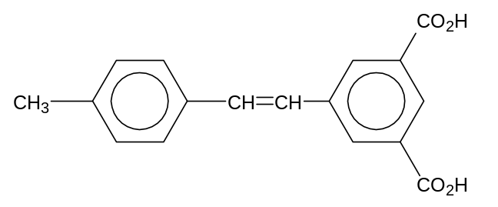  compound H
A | bromine | B | ethanol
C | hydrogen bromide | D | steam

19 | The following compound is tested with two reagents separately.  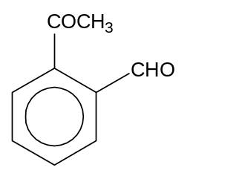  What are the expected observations?
   | Warm with Fehling’s reagent | Warm with Tollens’ reagent
  A | brick-red precipitate | silver mirror
  B | no precipitate | silver mirror
  C | brick-red precipitate | no silver mirror
  D | no precipitate | no silver mirror

20 | Compound J has the following structure.  1 2 3 4  CH₃CH(OH)CH=CHBr  Which statement is not correct for compound J?
  A | None of its structural isomers reacts with 2,4-dinitrophenylhydrazine.
  B | The terminal carbon atom (4) has a trigonal planar geometry.
  C | J reacts with acidified potassium dichromate(VI).
  D | J exhibits geometrical isomerism.

21 | Which sequence shows the compounds in order of decreasing pK_{a} values?
  A | CH₃CO₂H > CF₃CO₂H > C₂H₅OH > C₆H₅OH
  B | CF₃CO₂H > CH₃CO₂H > C₂H₅OH > C₆H₅OH
  C | C₂H₅OH > C₆H₅OH > CH₃CO₂H > CF₃CO₂H
  D | C₆H₅OH > C₂H₅OH > CH₃CO₂H > CF₃CO₂H

22 | 1 mole of an organic compound K reacts with 2 moles of NaOH(aq) when heated. 1 mole of K also reacts with PCl₅ to produce 1 mole of HCl(g).  Which compound could K be?
A | 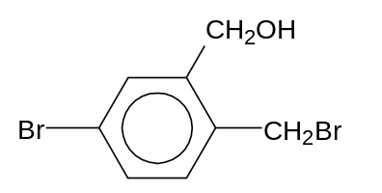 | B | 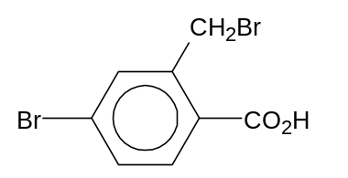
C | 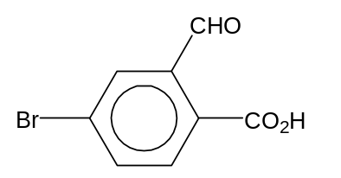 | D | 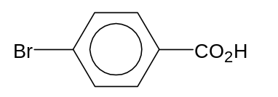

23 | Aspirin is a common analgesic used in the treatment of headaches and muscle aches.  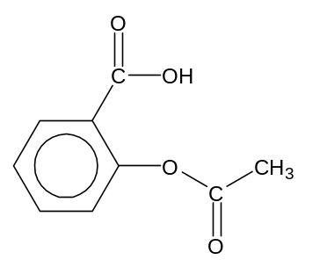  Which of the following is true about aspirin?  aspirin
A | It is soluble in water.
B | Its aqueous solution is acidic.
C | It gives a yellow precipitate when warmed with OH⁻/I₂(aq).
D | It gives an orange precipitate with 2,4-dinitrophenylhydrazine.

24 | The reaction scheme below shows the synthesis of compound S.  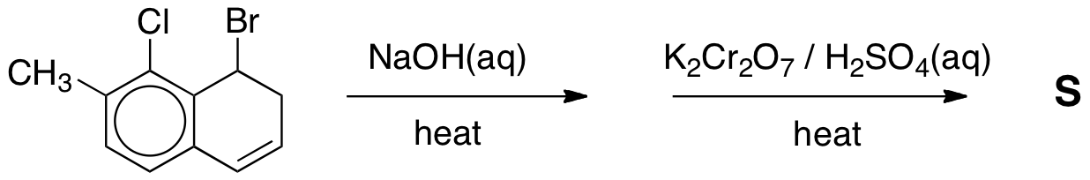  KMnO₄ / H₂SO₄ (aq)  Which of the following shows the structural formula of S?
A | 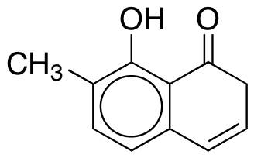 | B | 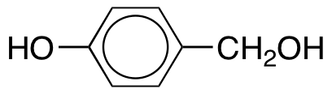
C | 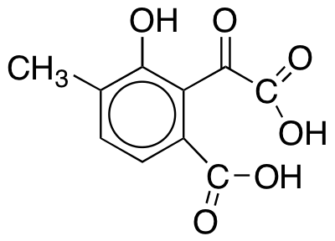 | D | 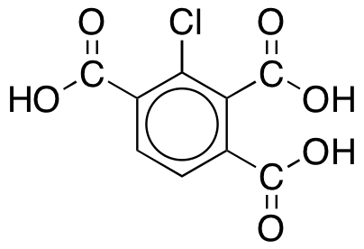

25 | Compound T has the following properties:  (i) it does not decolourise aqueous bromine;  (ii) it produces an effervescence when reacted with Na₂CO₃(aq), and  (iii) it decolourises hot acidified KMnO₄(aq).  Which of the following can be T?
A | 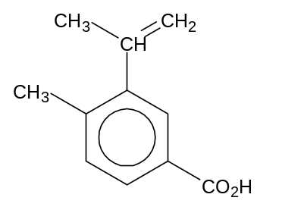 | B | 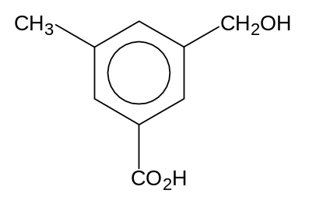
C | 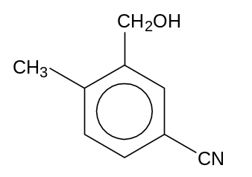 | D | 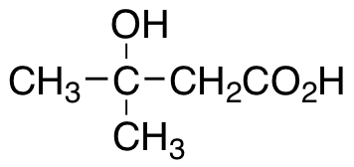

Section B
For each of the questions in this section, one or more of the three numbered statements
1 to 3 may be correct.
Decide whether each of the statements is or is not correct. (You may find it helpful to put a tick against the statements that you consider to be correct).

The responses A to D should be selected on the basis of
A | B | C | D
1, 2 and 3 are correct | 1 and 2 only are correct | 2 and 3 only are correct | 1 only is correct
No other combination of statements is used as a correct response.

26 | The conversion of CrO₄²⁻(aq) into Cr₂O₇²⁻(aq) is represented by the following equation:  2CrO₄²⁻(aq) + 2H⁺(aq) ⇌ Cr₂O₇²⁻(aq) + H₂O(l)  yellow orange  Which statements are true of this reaction?
1 | Addition of OH⁻(aq) to Cr₂O₇²⁻(aq) causes a change of colour.
2 | CrO₄²⁻(aq) acts as a Brønsted base.
3 | The conversion of CrO₄²⁻(aq) into Cr₂O₇²⁻(aq) involves a change of oxidation state.

27 | Magnesium reacts readily with dilute hydrochloric acid to form magnesium chloride and hydrogen.  Mg(s) + 2HCl(aq) → MgCl₂(aq) + H₂(g)  The standard enthalpy change for this reaction can be measured in the laboratory.  What further information is needed in order to calculate the standard enthalpy change of formation of magnesium chloride?
1 | ΔH_{f}º for HCl(aq)
2 | ΔH_{f}º for H₂(g)
3 | first and second ionisation energies of Mg

The responses A to D should be selected on the basis of
A | B | C | D
1, 2 and 3 are correct | 1 and 2 only are correct | 2 and 3 only are correct | 1 only is correct
No other combination of statements is used as a correct response.

28 | A theoretical reaction involves A + B → product.  The rate equation is: Rate = k[A]^{p}[B]^{q} and the units of the rate constant, k, are (mol dm⁻³)^{r} min⁻¹.  Which sets of the values of p, q and r fit the above information?
   | p | Q | r
  1 | 0 | 1 | 0
  2 | 1 | 2 | −2
  3 | 2 | 0 | −1

29 | A mixture of two oxides of Period 3 elements is added to water. The solution formed is almost neutral.  What could the constituents of the mixture be?
1 | Na₂O and P₄O₁₀
2 | MgO and SiO₂
3 | P₄O₁₀ and SO₃

30 | Which of the following statements are true regarding compound Z?  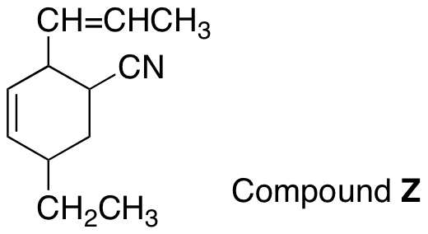
1 | A molecule of Z contains four π bonds.
2 | Z can exist as four cis-trans isomers.
3 | Z can be oxidised by acidified potassium dichromate(VI).

~ End of Paper 1~

